W-13
11 PHYSICS ATAR
ASSIGNMENT 5: ELECTRICITY

NAME: DUE DATE: TOTAL: 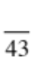

1. Draw the electric field associated with the following charged objects.

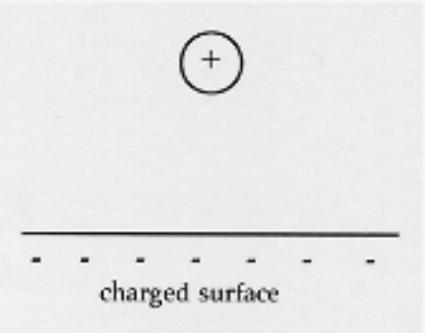
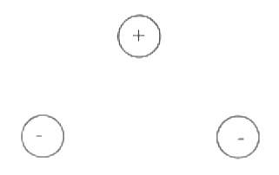
(a) (b)

(4)

2. (a) Explain why a plastic ruler that has been rubbed on a woollen jumper can attract small pieces of
paper. A diagram may help your explanation.

(HINT: Some degree of "charge separation" will occur on the paper.)

(3)

(b) Why does this not work very well if the air has high humidity?

(2)
3. A particle accelerator has an anode and cathode separated by 0.500 m in a vacuum as shown. An ion
of +2 charge and mass 6.68 x 10⁻²⁷ kg is introduced near the anode and accelerated towards the
cathode by a high potential difference V.
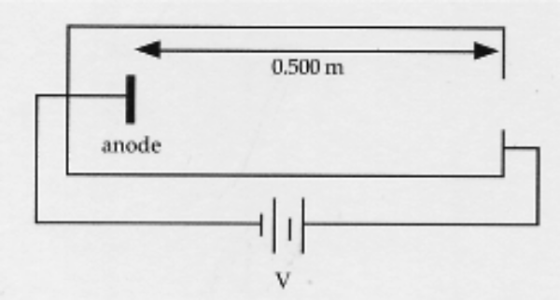

(a) Explain why the charged ion moves between the anode and the cathode.

(2)

(b) Calculate the potential difference required to accelerate the ion to 0.750 times the speed of light.

(3)
4. A group of students were given the task of identifying the metal used in a piece of wire by determining its
resistivity. Using multimeters to record the voltage and current for a variety of lengths of the wire, they obtained
the results show below. Ohm's Law was used to calculate the resistance R. The diameter of the wire was
measured as 0.490 mm with a micrometer.
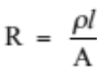

Length (l) (m) | Resistance (R) (x 10⁻² Ω)
0.100 | 1.51
0.200 | 2.92
0.300 | 4.44
0.400 | 5.94
0.500 | 7.38
0.600 | 8.90

(a) Graph these results, with R on the vertical axis. (3)


(b) Use the graph to determine the resistivity of the metal in the wire, and hence name the metal.

(4)

5. A compound circuit is set up as follows. The current through the 18.0 Ω resistor is 0.333 A.

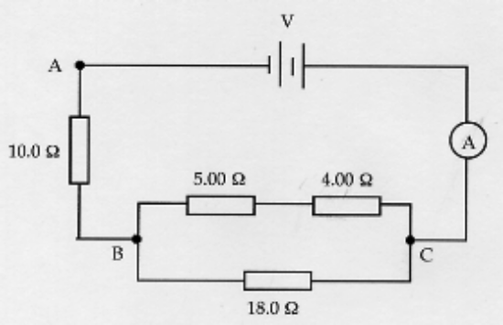

(a) Calculate the potential drop across the 18.0 Ω resistor.

(2)
(b) What current is measured on the ammeter?

(3)

(c) Determine the potential difference across the electricity source.

(3)

(d) What power is consumed within this circuit?

(2)
6. A solar hot water system has a 3.60 kW heater that is used to heat water overnight if needed. It operates at
2.40 x 10² V. The water is heated from 15.0 °C to 70.0 °C overnight, using 6.86 x 10⁷ J of energy. Assume
100% of the electrical energy is used to heat the tank.

(a) Calculate the time taken to heat the water.

(2)

(b) If the cost of a unit of electricity is 13.47 cents, calculate how much it costs to heat the water.

(2)

(c) Determine the resistance of the heater unit.

(2)

7. Explain why an earth leakage device (ELD) or a residual current device (RCD) is far more effective
than wire fuses in protecting humans from electric shocks in the household. Comment on how each
each device works to protect us.

(4)

8. Why is a double throw (pole) switch safer than a single throw (pole) switch?

(2)

